GA1

Meet the Chairs

Co President - Pesala Welangalle

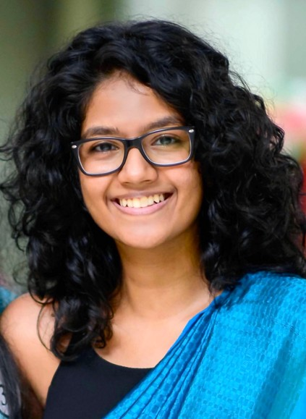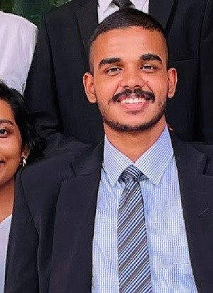Co President - Naveera Abhayawickrama

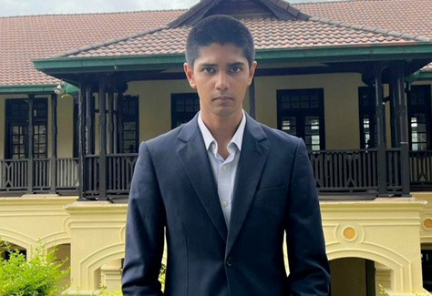Vice President - Parinda Ratnayake